Title

Author^{1,*}, Author², …

¹ Affiliation
² Affiliation
³ …
⁴ …

* corresponding author’s email:

Abstract (max 250 words)

Text of the abstract

Keywords: Keyword 1, Keyword 2, Keyword 3, Keyword 4, Keyword 5

1. Introduction

Text………………………………………………………………………………………………………………………………………………………………………………………………………………………………………………………………………………………………………………………………………………………………………………………………………………………………………………………………………………………………………………………………………………………………………………………………………………………………………………………………………………………………………………………………………………………………………………………………

2. Section title

Text………………………………………………………………………………………………………………………………………………………………………………………………………………………………………………………………………………………………………………………………………………………………………………………………………………………………………………………………………………………………………………………………………………………………………………………………………………………………………………………………………………………………………………………………………………………………………………………………

2.1 Sub-Section title

Text………………………………………………………………………………………………………………………………………………………………………………………………………………………………………………………………………………………………………………………………………………………………………………………………………………………………………………………………………………………………………………………………………………………………………………………………………………………………………………………………………………………………………………………………………………………………………………………………

- text……..;
- text……..;
- text……..;

or

- text……..;
- text……..;
- text……..;

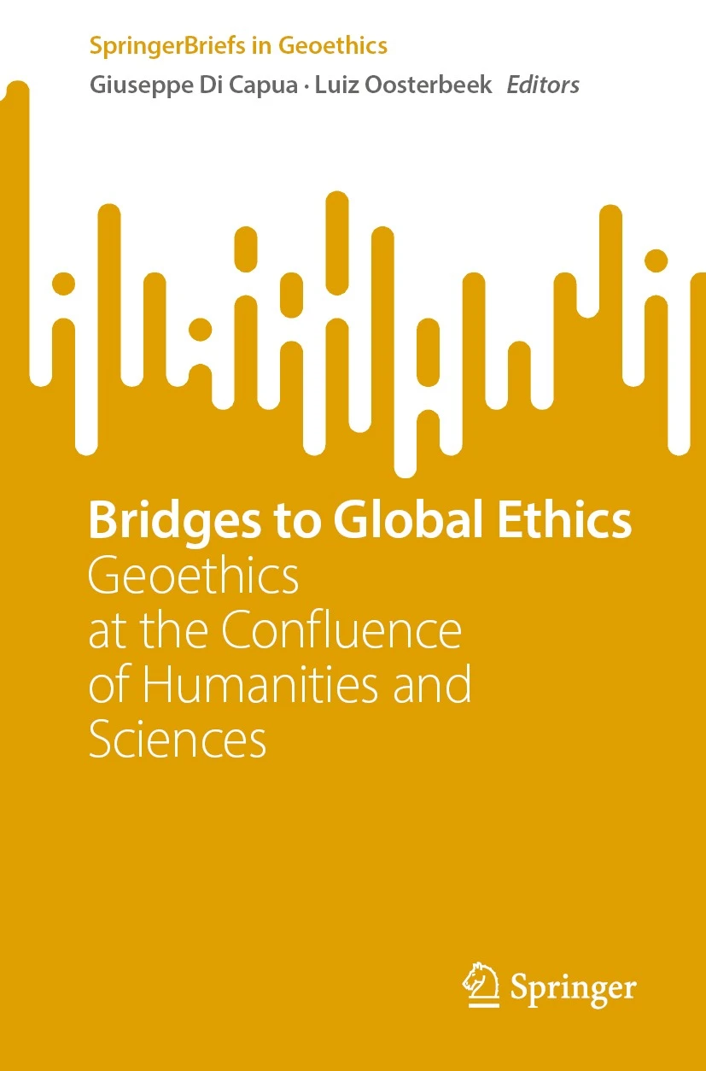

Figure 1. Caption.

Table 1. Caption.

Text | Text | Text

3. Conclusion

Text………………………………………………………………………………………………………………………………………………………………………………………………………………………………………………………………………………………………………………………………………………………………………………………………………………………………………………………………………………………………………………………………………………………………………………………………………………………………………………………………………………………………………………………………………………………………………………………………

Acknowledgements.
Text…………………………………………………………………………………………………………………………………………………………………………………………………………………………………………………………………………………………………………………

References (instructions below)

Manuscript should make proper and sufficient reference to the relevant formal literature.

Works cited in a manuscript has to be accepted for publication, published already, or in press. Works that are at review should not be cited in the references but can be referred to as personal communications. Works "submitted to", "in preparation", "in review", or only available as “preprint” cannot be included in the reference list. Theses and unpublished reports may be cited as references only if they are publicly available online. Otherwise they should be detailed in the acknowledgements.

In-text citations can be displayed as “Smith (2009)”, or “(Smith, 2009)”. If the author's name is part of the sentence structure only the year is put in parentheses. If the author's name is not part of the sentence, name and year are put in parentheses. If you refer to multiple references at the same position all references are put in parentheses separated by semicolons “(Smith, 2009; Mueller et al., 2010)”.

References have to be listed alphabetically at the end of the manuscript under the first author's name. References should follow the style of examples below and the DOI number for a paper should be given at the end of the reference if available (example, https://doi.org/10.4401/ag-6099):

Book

Passmore J.A. (1974). Man’s Responsibility for Nature: Ecological Problems and Western Traditions. Duckworth, London.

Wyss M. and Peppoloni S., eds. (2014). Geoethics, Ethical Challenges and Case Studies in Earth Sciences. Elsevier, Amsterdam. https://doi.org/10.1016/C2013-0-09988-4

Paper in a journal

Lenton T.M., Rockström J., Gaffney O., Rahmstorf S., Richardson K. et al. (2019). Climate tipping points — too risky to bet against. Nature, 575, 592-595. https://doi.org/10.1038/d41586-019-03595-0

Peppoloni S. and Di Capua G. (2012). Geoethics and geological culture: awareness, responsibility and challenges. Annals of Geophysics, 55(3), 335-341. https://doi.org/10.4401/ag-6099

Paper in a book or memoir

Peppoloni S., Bilham N., and Di Capua G. (2019). Contemporary Geoethics within Geosciences. In: Bohle, M. (Ed.), Exploring Geoethics: Ethical Implications, Societal Contexts, and Professional Obligations of the Geosciences. Palgrave Pivot, Cham, pp. 25-70. https://doi.org/10.1007/978-3-030-12010-8_2

Full paper, extended abstract or abstract in conference proceedings

Bellaubi F., Mallarach J.M., and Sardá R. (2020). A geoethical approach to the governance of social-ecological systems: the case of Delta del Tordera (Cataluna). Actas XI Congreso Ibérico de Gestión y Planificación del Agua, pp. 787–800. https://www.silene.ong/wp-content/uploads/2020/09/Geoethical_Tordera_Bellaubi_Mallarach_Sarda_2020.pdf (accessed 9 March 2022).

Drąsutė V., Corradi S., Peppoloni S., Di Capua G. (2020). Geoethics and New Medias: Sharing Knowledge and Values. In: 10th The Future of Education International Conference – Virtual, Conference Proceedings, Filodiritto Editore, Bologna. https://conference.pixel-online.net/FOE/files/foe/ed0010/FP/6590-SCI4598-FP-FOE10.pdf (accessed 8 January 2022).

Woo K.S. (2017). Role of IUCN WCPA Geoheritage Specialist Group for geoheritage conservation and recognition of World Heritage Sites, Global Geoparks and other protected areas. Geophysical Research Abstracts, vol. 19, EGU2017-1137.

Website

IAPG website. International Association for Promoting Geoethics: https://www.geoethics.org (accessed 15 February 2022).

