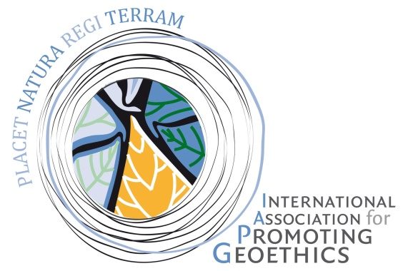

***18 October 2018***

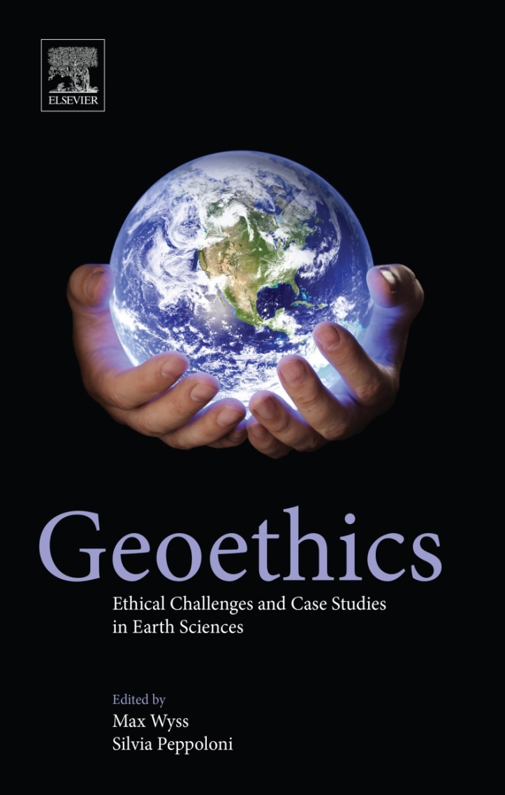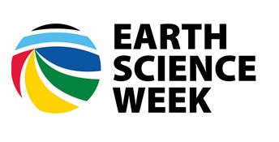

**GEOETHICS IS …**

***#geoethicsday2018***

***http://www.geoethics.org/geoethics-day***

***International Geoethics Day***